Portal Page Wireframe
Caleb Sullivan | WDD 130 | Progress Check 100
HEADER
LOGO | Caleb Sullivan  WDD 130

NAV
Home | WWR | ICE | About Me

MAIN
Main content

FOOTER

Design
Caleb Sullivan | WDD 130 | Progress Check 100
Logo
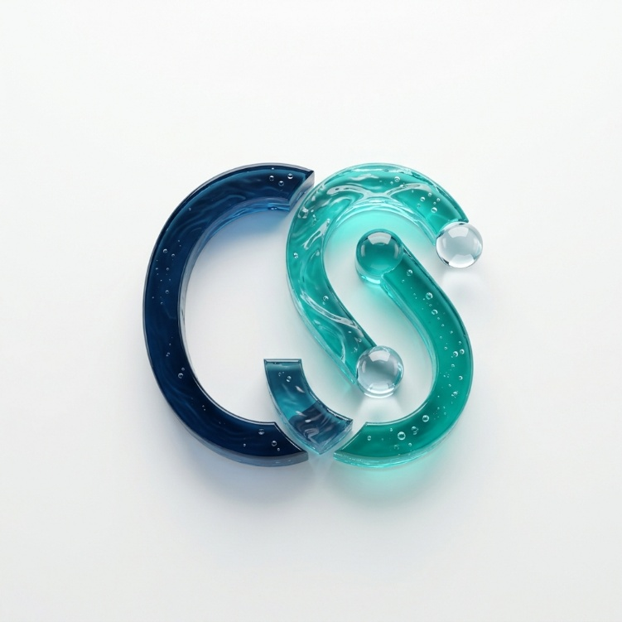
Color Scheme
Swatch | Name | Hex
 | Navy | #1B2A4A
 | Steel Blue | #3E5C76
 | Teal | #2A9D8F
 | Light Teal | #A8DADC
 | Off-White | #F4F7F6
 | Charcoal | #2B2D42
Fonts
Use | Font
Headings | Montserrat
Body text | Open Sans

